Session 6

- Sub Query
- Top Clause
- Random Selection
- Ranking Functions

Sub Query:
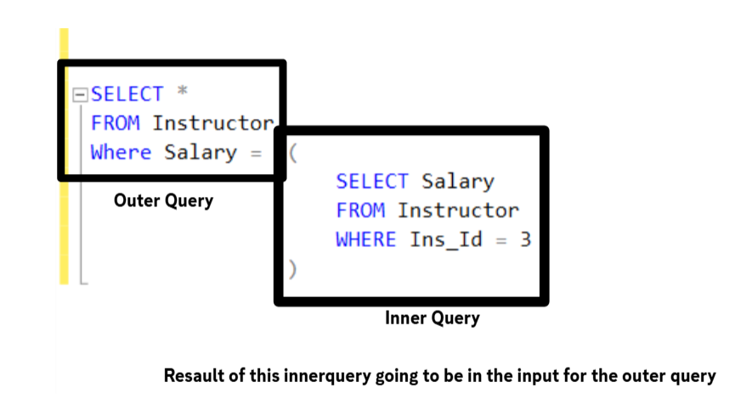
Max 32 subquery
These is a lot of things that u can do with subqueries you cannot do with join and these is something u do with subquery you can do with join
it depends on the amount of data you are working with
Sub Query can be used within SELECT, UPDATE, INSERT, and DELETE statements
and can be used within
FROM, WHERE, SELECT, HAVING, and JOIN
TOP Clause
This Keyword returns a specific number or percentage of rows starting from the top of the result
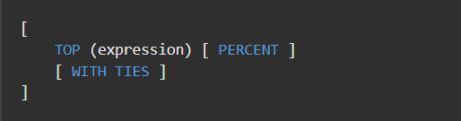
expression is a numeric value which is a constant or a variable
PERCENT optional if you added it to the statement it will make the expression a percentage
WITH TIES Optional and if you added it , depending on the order by if anythere is any ties in values it will return the tied rows
Random Selection:
Selecting random results ever time the query is executed
We can do it using the NEWID( ) NEWSEQUENTIOLID( ) function
this function do generate random ID every time you execute the query
this number is 36 characters booking 16 byte from memory
the NEWSEQUENTIOLID( ) can only be used with default constraint on table columns of type identifier
NEWID() ID FORMATE ########-####-####-####-############
8 4 4 4 12

How can we use NEWID( ) to generate random selection
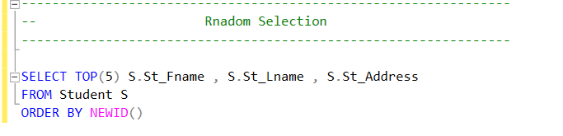
First Execution Second Execution
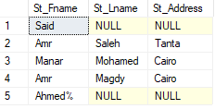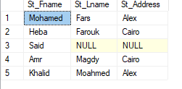

Ranking Functions
The first 3 have the same syntax
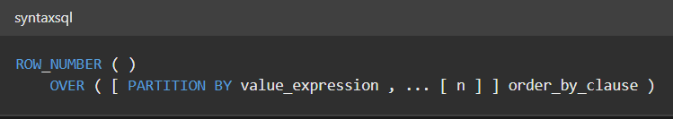
On the first 3 we going to try ranking students based on grades
- ROW_NUMBER( )
Assigns a sequential integer to each row within a partition
Even with duplicates values each row will get a unique integer number
- DENSE_RANK( )
Do the same as ROW_NUMBER( ) But if there is any ties in the value the rank assigned to this tied value will be the same rank as its group
- RANK( )
The same as DENSE_RANK( ) But it deals with ties a bit deferent as if the ties valued ended it will give the next row a new ranking based on the row number
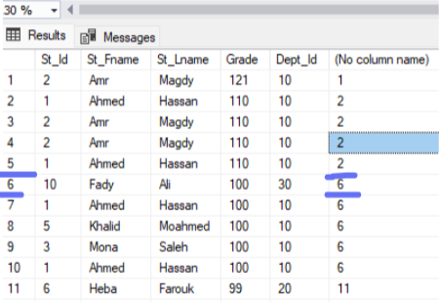
- NTILE( )
Devide rows returned to part or pages approximately
If the number of rows u asked to return is not perfectly divided by the number u specified in the NTILE() It will split the remaining number of rows between
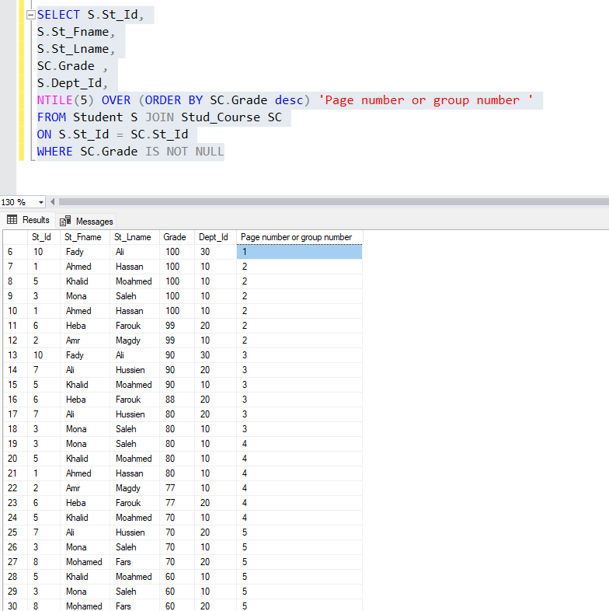
30 rows devided by 5 is 6 groups

